Assignment #5 Tableau U.S. Agriculture by Joshua Troup

Identify the county where there is a high ratio of fast food restaurants

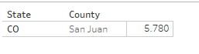

**San Juan Colorado --- 5.780**

County with highest ratio in Pennsylvania?

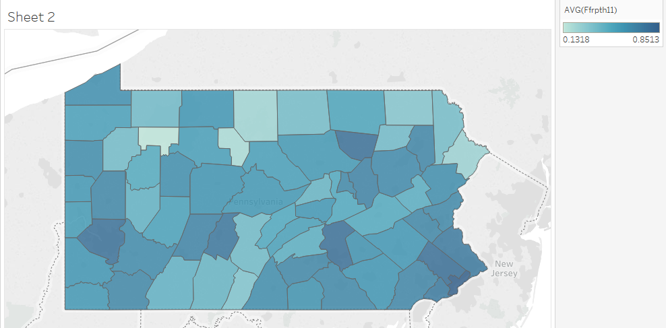

**Philadelphia---.8513**

Is this visually appealing and easier to comprehend than the textual? Comment.

**Yes the graph above is much more appealing and better to gain quick insight on which counties have the highest or lowest ratios. Bar graph may be better suited to pick out the top contenders immediately but the geographic display gives the viewer a understanding of the entire state by county.**

The average number of fast food restaurants per population in each state?

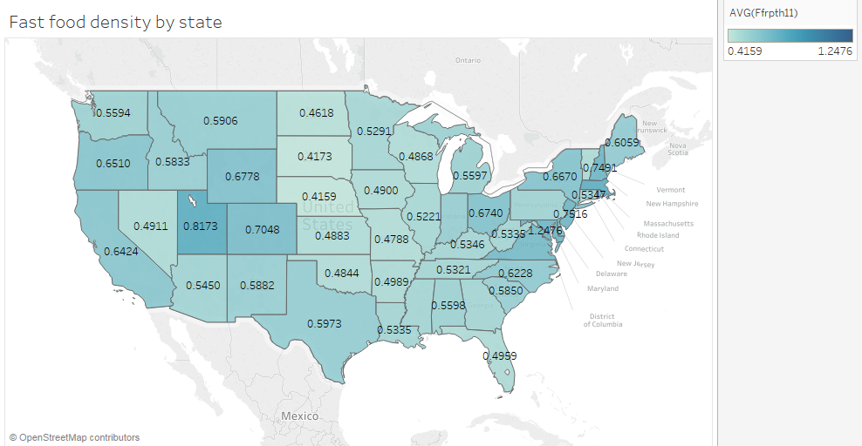

**Highest = DC---1.2476**

Is there a relationship between Diabetes rates and Obesity rates?

Is there a relationship between obesity and diabetes? Positive or negative?

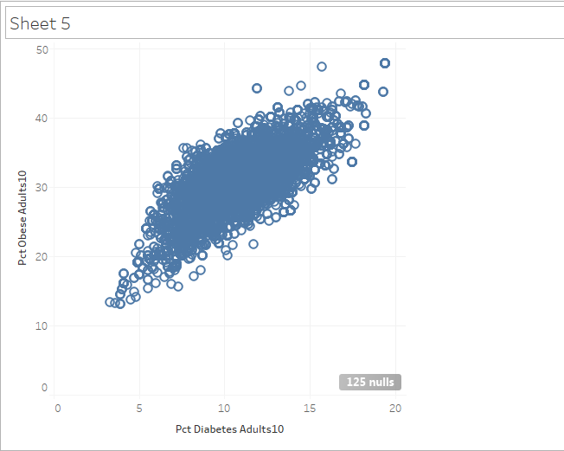

**Yes the scatter plot above displays a positive relationship between obesity and diabetes.**

Do fast food restaurants have a relationship with obesity rates?

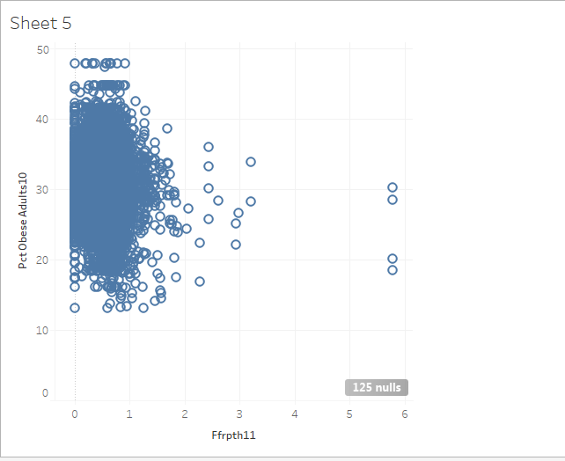

**Density of fast food restaurants seem to have no relationship with obesity rates.**

Now sort the 2 columns to show the highest county on top and comment on your analysis insights. Which county tops the list in each column

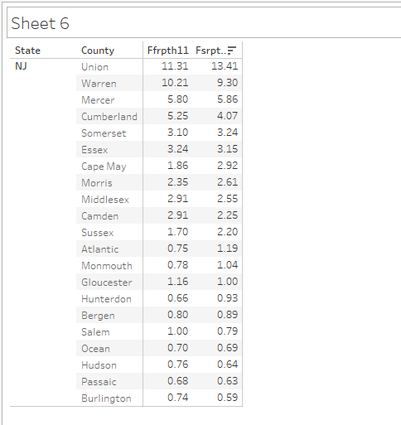

**Union county in New Jersey has the highest percentage of fast food restaurants per 1000 people and percentage of full service restaurants per 1000 people. Warren county is relatively close to Union county based off of percentages. The remaining counties fall drastically.**